**DAILY ONLINE ACTIVITIES SUMMARY**

|  |  |  |  |  |  |  |  |  |
| --- | --- | --- | --- | --- | --- | --- | --- | --- |
| **Date:** | **28-5-2020** | | | | | **Name:** | **Likhitha.M** | |
| **Sem & Sec** | **6th sem ‘A’** | | | | | **USN:** | **4al17cs046** | |
| **Online Test Summary** | | | | | | | | |
| **Subject** | | **Operating systems** | | | | | | |
| **Max. Marks** | | **30** | | **Score** | | | **24** | |
| **Certification Course Summary** | | | | | | | | |
| **Course** | **Python for machine learning** | | | | | | | |
| **Certificate Provider** | | | **Great learning** | | **Duration** | | | **1 week** |
| **Coding Challenges** | | | | | | | | |
| **Problem Statement:**  1.Python program to find digital root of a number  2.JAVA PROGRM-BALANCED BRAKET | | | | | | | | |
| **Status: completed** | | | | | | | | |
| **Uploaded the report in Github** | | | | | **yes** | | | |
| **If yes Repository name** | | | | | **https://github.com/likhithaMantaral/Daily-status** | | | |
| **Uploaded the report in slack** | | | | | **yes** | | | |

Online test Details:

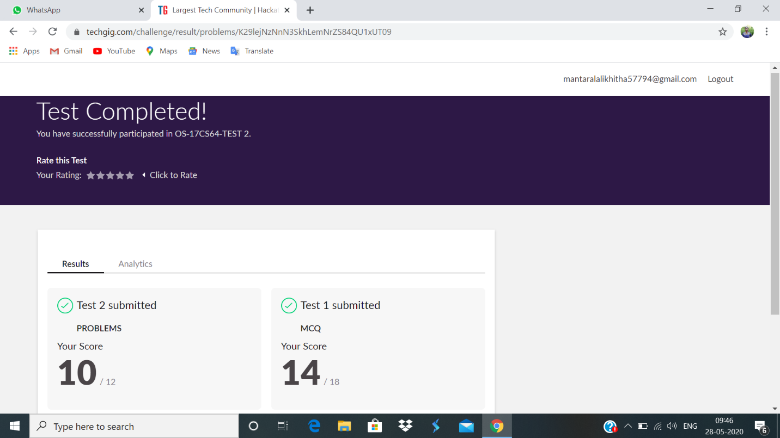

Certification Course Details:

Successfully completed python for machine learning course.

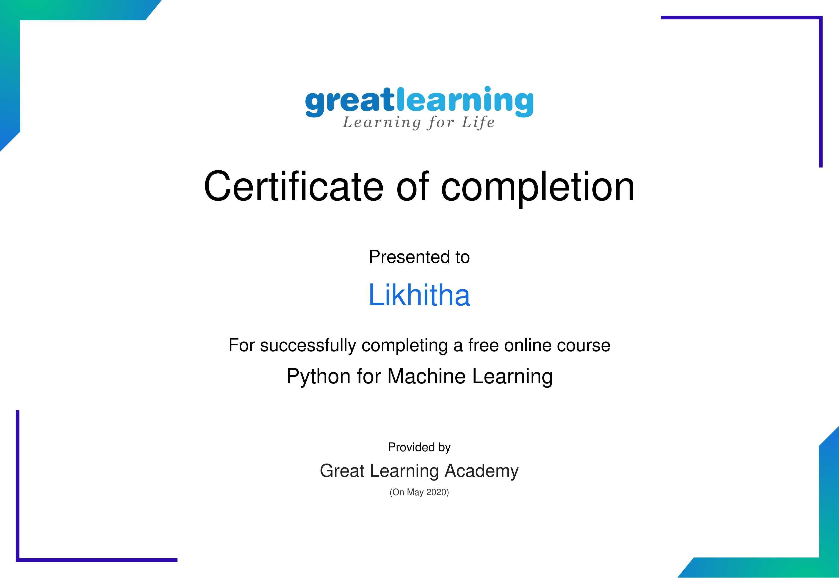

**Coding challenge:**

**1.**

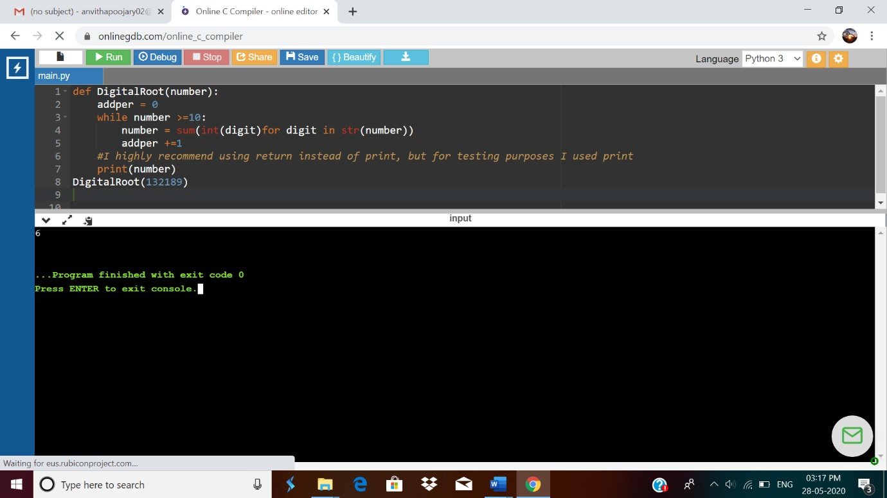

2.

